Initially after loading page

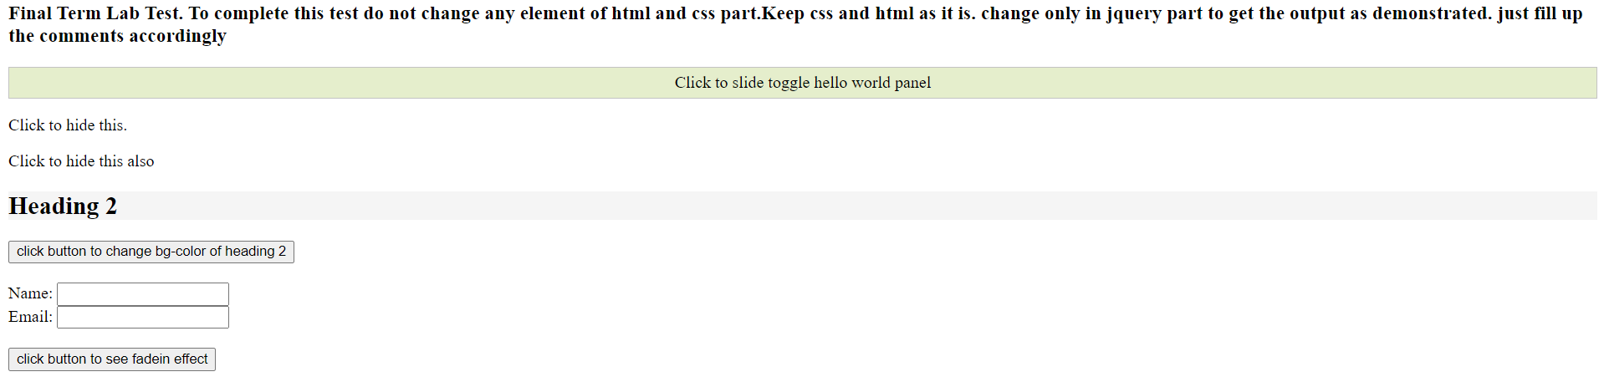

After jQuery effect

